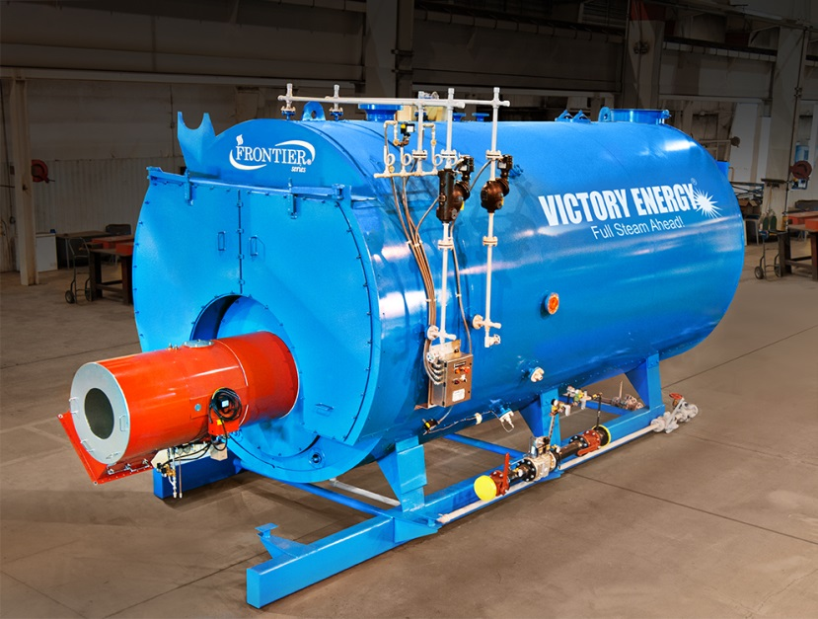

For Immediate Release:

Collinsville, Oklahoma
Contact: Jeff Anderson 918.704.1439

Victory Energy Announces
A New Dryback Firetube Boiler Series

In response to market need and overwhelming customer requests, Victory Energy announces comprehensive plans to begin manufacturing dryback FRONTIER Series firetube boilers. This product line extension compliments Victory Energy’s already strong wetback firetube boiler capability.
“For years, we’ve been asked by customers to pursue the manufacturing of dryback firetube boilers. We feel the timing is right to enter the market with a more comprehensive strategy. This allows us to build on the success of Frontier Series wetback boilers to now have a complete and deeper firetube product offering,” stated John Viskup, President and CEO.
All Victory Energy firetube boilers will be manufactured in a dedicated factory just an hour drive from our corporate headquarters. “Before embarking on this decision, we took a strong look at the state of the firetube business. We’ve done extensive work on developing smart processes with technology and manufacturing advances, coupled with equipment investments, to arrive at a cost position that works for our company and our customers. Much as we’ve realized with our industrial boiler product line, we plan to become a force to be reckoned with in the firetube space,” remarked Viskup.
The new dryback FRONTIER firetube boiler offering is being expanded to meet virtually all commercial and industrial applications ranging from 50HP to 2,500HP, making Victory Energy an even more complete firetube boiler provider. The company is planning to develop a dedicated firetube selling organization comprised of representatives who currently sell the Victory Energy industrial boiler line, as well as new firetube-focused-only sales reps. “Selling firetube boilers requires having a vast number of sales reps on the street calling on commercial applications. We’re aggressively looking for the best representatives to deliver on this opportunity,” added Viskup.
####

